**EXP 2 EMPLOYEE DATABASE**

**Aim:**

Consider the employee database given below

**emp** (emp_id,emp_name, Street_No, city)

**works** (emp_id, company name, salary)

**company** (company name, city)

**manages** (emp_id, manager_id)

**Note: Emp_id should start with ‘E’ in Emp table and emp_id in works table must be the emp_id from emp table .emp_id and manager_id in manages table must be the emp_id from emp table**

1. Find the names of all employees who work for SBI.

**Query**

select emp_name from emp,works where company_name='SBI' and emp.emp_id=works.emp_id;

**Output**



1. Find all employees in the database who live in the same cities as the companiesfor

which they work.

**Query**

select emp_name from emp,works,company where emp.emp_id=works.emp_id and emp.city=company.city and works.company_name=company.company_name;

**Output**



c. Find all employees who earn more than the average salary of all employees of their

company.

1. Give all managers of SBI a 10 percent raise.

**Query**

update works set salary=salary*1.1 where emp_id in(select manager_id from manages) and company_name='SBI';

**Output**

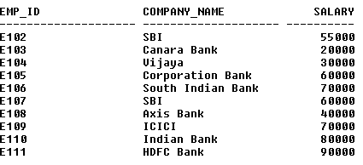

e. Find the company that has the most employees

**Query**

select company_name from works group by company_name having count(distinct emp_id)>=all(select count(distinct emp_id) from works group by company_name);

**Output**



f. Find those companies whose employees earn a higher salary, on average than the

average salary at Indian Bank.

**Query**

select company_name from works group by company_name having avg(salary)>(select avg(salary) from works where company_name='Indian Bank' group by company_name);

**Output**



g. Query to find name and salary of all employees who earn more than each employee

of ‘Indian Bank’

**Query**

select emp_name,salary from works,emp where salary>(select max(salary) from works where company_name='Indian Bank' group by company_name) and emp.emp_id=works.emp_id;

**Query**

